NAVIGATE THE HOLIDAYS WITH MORE EASE – KEEP YOUR BLOOD SUGAR BALANCED

When we are grieving, one of the first things that goes out of the window is eating at regular times each day. Which is unfortunate as a regular daily meal routine is the very thing that can prevent us from grazing all the time and overeating. Especially around Christmas.

Timing our meals so that they happen at about the same time each day is one of the easiest ways to help our energy, mood, and emotions this time of year. Because it is all about blood sugar balance.

Our body loves routine and irregular mealtimes affect our health and wellbeing – on every level. When we don’t have breakfast or a truly nourishing warm meal at lunchtime, we tend to snack more. Why? Because our needs are not met and we are constantly hungry.

Now imagine this physical hunger combined with our emotional hunger when we are grieving. With all the emotional triggers of Christmas thrown into the mix.

With so much food for the taking, it becomes very tempting – and easy – to try and satisfy all our ‘hunger’ with food. However, grabbing food at random to satisfy our emotional needs can become a real problem during the festive season.

Because grazing all through the holidays and indulging too much in traditional comfort food, such as pizza, pasta, cookies, or bread, causes a constant blood sugar rollercoaster. And a true ‘double whammy’ when our emotions are already all over the place.

Since grief does not have a schedule, we are left with one choice only if we want to get through the coming season in a better shape – sticking to a regular eating routine as best we can.

Here are some tips on how you can prepare yourself for all this ‘festive food extravaganza’ and curb emotional eating so that you feel more in control:

- Be mindful

- Bring awareness to what, when and how you eat. Ask yourself: ‘Am I truly hungry?’ before you put food in your mouth. Also reflect on what kind of emotion you are trying to satisfy by eating. This Mindful Eating Journal can help you with this: http://ow.ly/KH4N50LTOHz

- Once you have chosen what food you are going to eat, simply enjoy it. Don’t feel guilty but stop when you are getting full. And notice how the food you are eating makes you feel.

- Be prepared

- Base all your meals on a combination of protein, fruit or vegetables, and small amounts of healthy oils to keep your tummy nicely full and your blood sugar stable.

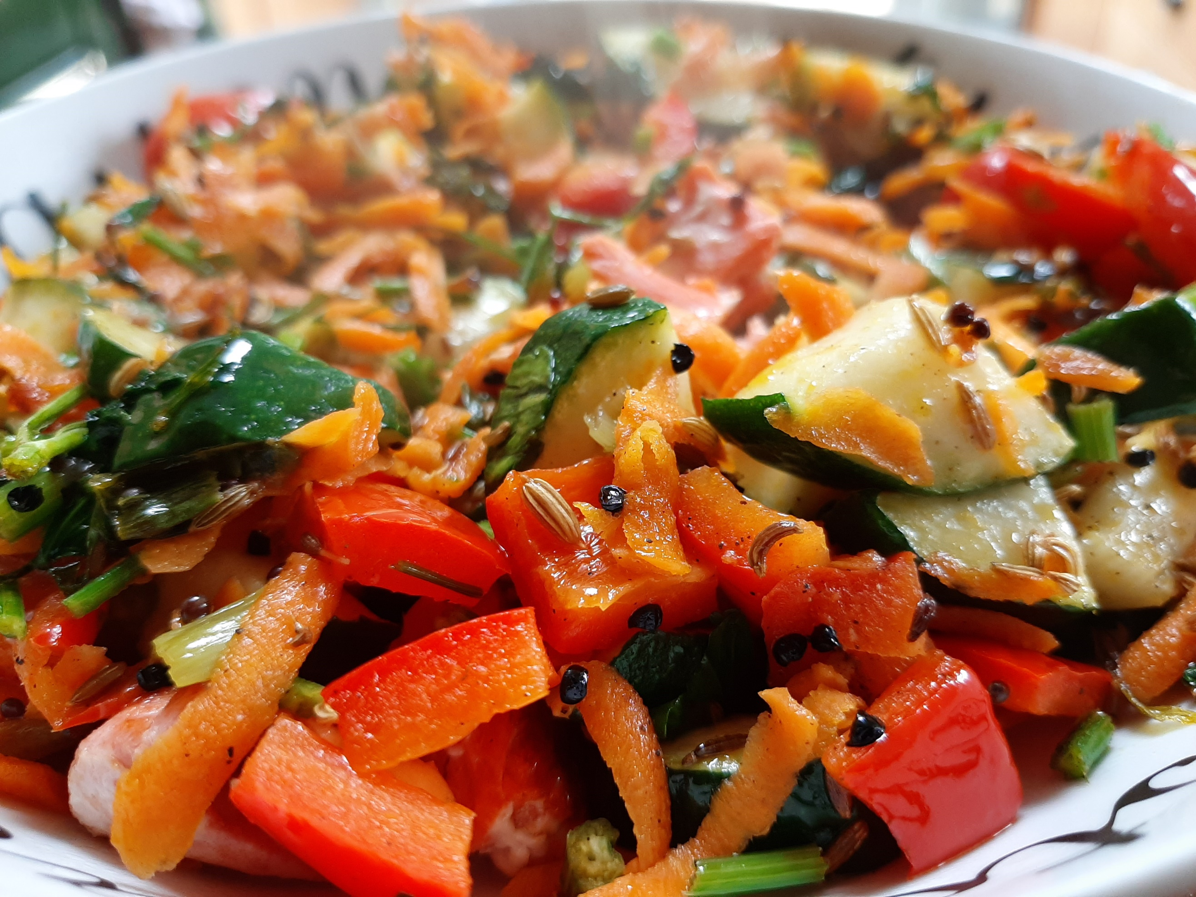

- Plan out your meals for the next day to avoid erratic eating or skipping meals.
Get all the ingredients in for a hearty slow-cooked stew or make a tasty stir-fry with leftovers from Christmas.
- Make a batch of healthy snacks such as energy balls or Chocolate Avocado Truffles. Keep them in your fridge or freezer for whenever you feel like comfort eating.
- Prepare yourself mentally for how you are going to deal with eating out. Are you going to stick to the 80:20 rule, being stricter about what you eat at home and going with the flow when you are out and about? Alternatively, you can choose healthier foods from the menu or party buffet.
- The same 80:20 rule can apply to staying over with friends and family. Decide beforehand.
- Plan how much alcohol you are going to have and when. Watch out for my tips on this topic.

At the end of the day, it is all about balance. The more you can control your blood sugar by eating on schedule during the holidays, the better you will feel. Meanwhile, there is no need to deprive yourself. Treat yourself to some deliciously healthy food by trying some of the festive recipes in my Christmas Survival Guide: http://ow.ly/y0sj50LTO2C

Need more self-care tips on how to survive Christmas without your loved one? Come and join my free webinar: http://ow.ly/WlUa50LTNYh

